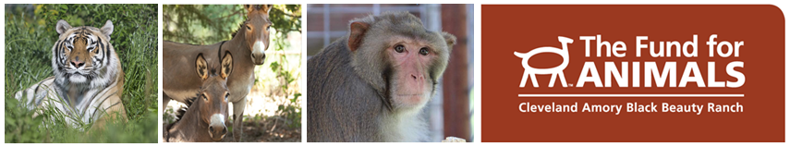
Cleveland Amory Black Beauty Ranch
Internship Opportunities

The Cleveland Amory Black Beauty Ranch (CABBR) is a world-renowned animal sanctuary that is home to over 800 domestic and exotic animals, many of whom have been rescued from near-death situations such as slaughterhouses, biomedical research laboratories, and trophy hunting ranches.

Animal Care Interns have the opportunity to gain valuable hands-on animal care experience, knowledge about a variety of species, and exposure to the operations of an animal care center.

Some internship responsibilities include:
- Preparation of diets and medications
- Complete daily husbandry practices, provide behavioral enrichment and stimulation on a daily basis and at times participate in habitat modifications
- Gain knowledge on animal behavior
- They will participate in various classes taught by CABBR animal care professionals
- Assist in record keeping: diet intakes, medication records, enrichment logs, behavior observation logs
- Complete general housekeeping tasks
- Assist with administering minor medical treatments
- They will be required to complete an intern project such as building a bobcat cave, primate enrichment or goat platforms to name a few

The Animal Care Interns rotate between our three animal care departments: Equine, Primate, and Wildlife. They will spend 1 month in each department working alongside professional caretakers learning about the various species in their care.

- Equine Department: CABBR is one of the largest equine sanctuaries in the United States, home to nearly 500 horses and donkeys, who are able to roam across hundreds of acres of land.
- Primate Department: CABBR is currently home to non-human primates including gibbons and several species of monkeys, primarily rhesus macaques and capuchins.
- Wildlife Department: Caring for the majority of species at CABBR including, but not limited to, tigers, bears, bobcats, bison, various exotic hoofstock, and ostriches. In addition, the Wildlife department is responsible for the daily husbandry of the Sanctuary’s farm animals—cows, pigs, goats, sheep, turkeys, chickens, and a llama.

For more information on Animal Care Internships, follow this link:
http://www.fundforanimals.org/blackbeauty/internships/
